Listening to the Lord, Christian Meditation Group.
Christ Church Higher Bebington, Kings Road, CH64-8LX
(Beginning 4pm on 18th August 2019, then every third Sunday of the month at 4pm)

Have you ever thought about trying to connect with the Lord through an extended period of guided silence?
Our world today is busy, as is our lives, our families, our jobs, and even our minds. We race around in more ways than we realise and even when we stop or slow down, our thoughts don’t, and this is draining.
Christian Meditation comes in various forms which cover guided reading, contemplative prayer, chanting and others, but the foundations for them all can be found in silence during which we can really experience the Lord. When you get a moment before the class try and read the story of when Elijah Meets God at Horeb, for he does so not in great winds or earthquakes but in the “sound of sheer silence” (1 Kings 19:11-13)
The event will take place in the king’s hall during the afternoon and will include a talk about meditation at the beginning, followed by 40 minutes of silent, gently guided peace, and will then end with tea and coffee which will be provided.
In order to meditate and sit in peace, you will need to be comfortable, therefore although the hall will have blankets, cushions and mats scattered about with chairs available, you may wish to bring your own. And please wear something you may be comfortable sitting or kneeling in that is non restricting. Some people use meditation shawls, a cloak, prayer Alb’s, it really is up to you.
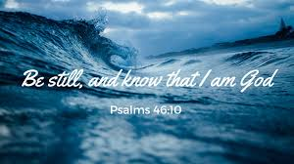
Please speak to the parish office or contact George on 07751 630 611

