WHY am I a Christian?

First off WOW, what a question to deal with, why am I a Christian? When Mike proposed this sermon series upon face value I thought “well this is going to be simple” but then it began to sink in, the depth of what this question can uncover, which will be different for each of us wont it. But regarding this, what indeed is making me follow a first century man from a land that until recently I had never been to, and indeed most people will not go to.

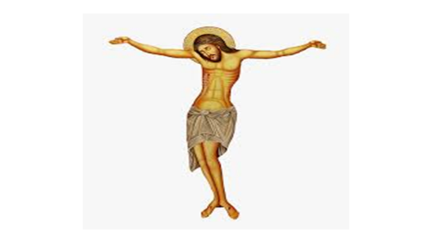
Now, to begin with I just want to tell you a little bit about by conversion, which unlike most people I did have what some would call a Damascus road type of conversion of sorts where one day this young man with absolutely no interest in the faith a went to bed after a shift and had an extremely powerful dream of Jesus hanging on the cross. It was quite possibly the strangest thing that ever happened to me at the time because one minute I threw my Ambulance uniform on the floor and crawled into bed and about what felt like a second later I was struggling to comprehend the reality of the dream that I was suddenly a part of. I remember the walk up a small hill and noticed a pair of feet just above head height, pinned to the cross. The breeze on my face was real, the sky was bleak and the pain on his face was clear. This man (me) who hated anything to do with the mention of G-d was suddenly in a dream face to face with his own saviour.
Was this dream the result of bad cheese? Was it the brain trying to process something I had subliminally taken in that day? Or was this dream real? I believe my encounter with Jesus and the dream leading up to the cross was indeed real which is testimony to how my life changed from then on.

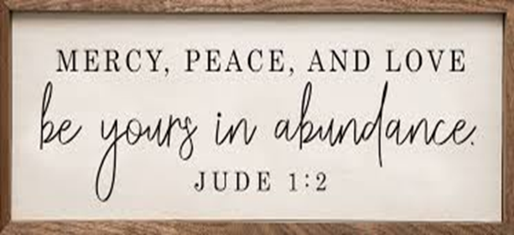
Something within me changed, I changed, I began to view the world differently, to view its people differently. In fact, peace and Mercy became two of the key driving forces in my life from that time onwards. And being in the emergency services, peace and Mercy was a very welcome set of standards indeed, especially in a role where brokenness, disharmony and lack of mercy is witnessed daily.

But this is How I became a Christian; the question is why am I a Christian?

Well some of you are probably sitting there waiting for me to say lines such as…

“The bible tells me so” or “Jesus came to save me from my sins” “The church is my home” etc. You know, those lines you expect a Christian and indeed a potential leader to come out with, well brothers and sisters these things are true, though I could elaborate on some of these things in many different ways regarding personal experience and interpretation, but to me the first reason I am a Christian is that my spiritual journey makes me a Christian.

You see, I started my journey off as a conservative evangelical, a strict bible based suit and tie Christian who stepped out of his old life and moved forward into this strange new place called the church and over time I began to walk a road closer to Jesus and deeper into his church. In doing this I realised that within the church I have a home, a place and a foundation of life and learning, and within Jesus I have forgiveness, love, and peace. Eventually I now identify myself as a Catholic Anglican, someone who sits close to the history, traditions, and spirituality of Rome but someone who is also a little open to all people, all spirituality’s, and all churchmanship’s. Which is why I love Christ church higher Bebington and I love you people, because here we have people who identify as liberal, conservative, evangelical, Pentecostal, and catholic and we all exist here in peace. This is no small thing can I add! This place, I believe is unique and it is this unique spiritual blend that we should hold onto, and indeed is one reason I am a Christian because like you all, my spiritual uniqueness sings a song that keeps me grounded and home, that keeps me with Christ and his church.

In our reading Jesus speaks of the Holy spirit being sent to be a counsellor and guide, It is this Holy Spirit who walks with us in our spiritual uniqueness, your uniqueness makes you a Christian too, and you should never feel ashamed or worried by your uniqueness, we all have gifts and these gifts make us the Christian we are, I like some people are gifted with dreams, visions, and spiritual experiences that until recently I didn’t really understand.
I now identify that my spiritual journey and uniqueness is a part of the answer to why I am a Christian.

Our spiritual experiences be they experienced in the everyday or in the strange shape us, don’t they? Our engagement in prayer, the sacraments, our conversations with brothers and sisters they all shape us and add to this story.

Dreams and things aside, I am a Christian because I also believe in Jesus’s message of peace. One of my favourite verses in the whole of scripture is from our Gospel reading today,

27 Peace I leave with you; my peace I give you. I do not give to you as the world gives. Do not let your hearts be troubled and do not be afraid.

How beautiful is this, I really reflect upon what this would have been like to hear it come from his mouth directly.

In the Benedictine tradition we look at peace from many angles and for me there are three circles of peace. There is the Internal peace from the Holy spirit that we all should try and strive for, so that nothing from this world shakes us or rocks our faith (if you master this one please do let me know), The external peace of Jesus Christ that makes us step out to try and heals relationships and tends to the oppressed, sick, lost, and hungry. And the wider peace of God the Father during this time of Pandemic, of riots in known places, of man’s inhumanity to man. How desperate are we to feel and hear this message of peace in today’s world, seriously, what is going on in 2020 when all seems so unpeaceful?
You and I can play a small part in the mission of the prince of peace can we not? Cast a stone into a still lake and the ripples go on and on do they not? What stone can you cast into that lake right now?

This brothers and sisters are another one of the key principles to my faith and why I am a Christian. And I have made it my “mission” so to speak of, to strive for and pursue the message of peace and to teach others to follow the prince of peace, our Lord Jesus Christ.

PEACE brothers and sisters, PEACE.

And finally, a somewhat simple answer to why I am a Christian, to me to not be a Christian is to stop breathing, it is the very air I breathe. I breathe in Jesus, I breath out Jesus. To me NOT becoming a Christian is never going to happen because choosing to breathe is not an option it just happens and will always happen. I cannot choose to stop being a Christian any more than I can choose to stop breathing. How I got through the first 21 years of my life without Jesus is a mystery to me, I must have been holding my breath for some time. Jesus is everything to me and my life is one constant circle of prayer, reflection, and repentance. I fail at this, we all fail at this there is none perfect at all, but I feel we have a duty to try and get as close to him as humanly possible, as it says in our reading that,

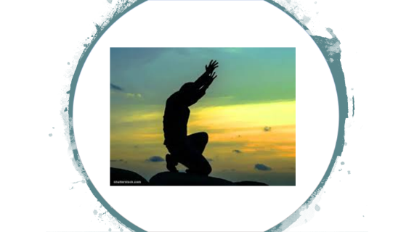
“I am in my father, and you in me, and I in you”

I feel so spiritually in love with the Lord that to not be a Christian is impossible. But this love and constant attempt at unity with Jesus does not make me float on a cloud of perfection, far from it. As I said, I have my faults, I have many of them as I am sure my wife will happily list of beginning at number 1…and probably going ending at 100. 😊 I also have my doubts about the faith, about church, the scriptures etc, ask mike and Eunice, they get these doubts regularly, usually at 3 am via email when I cannot sleep .

Strive to unite yourself with the Lord and get as close to him as possible.

So, in summary, I am a Christian because my spiritual experiences make me a Christian, and yours will too. Because I believe in Jesus Christ, and in the message of peace he brings to a broken world which I pray is a call we all take seriously each day, And because it is very much a part of my inner being.
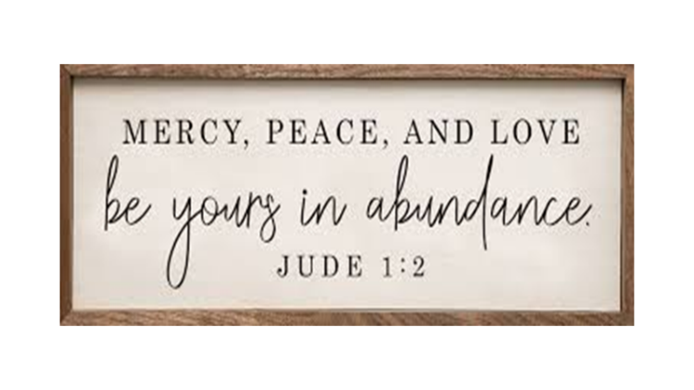

Let us pray…

