Sunday 31st January 2021 – Candlemas Luke 2: 22-40; Hebrew 2: 14-18
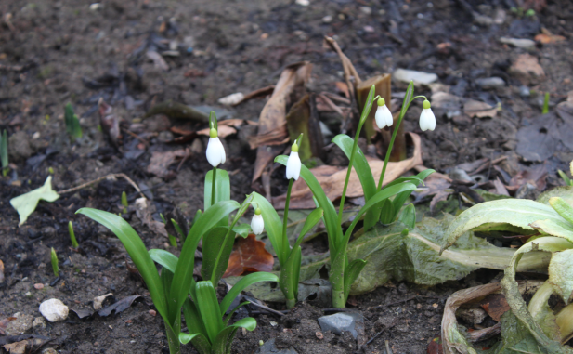
Today we’re celebrating Candlemas – the closest Sunday to February 2nd - which is an ancient festival marking the mid-point of winter, halfway between the shortest day and the spring equinox. It is a celebration of light and hope in the midst of darkness. Being 40 days from Christmas Day we recall it was the day when Jesus was presented in the Temple. Some Christian groups still observe it as the last day of Christmas before turning towards Lent and Easter.
Into the darkness comes hope! Did you know that Snowdrops were traditionally known as Candlemas bells? Have you noticed them yet emerging from the darkness and gloom? What a beautiful and encouraging symbol of hope, of new growth and new beginnings! Yes survival is possible despite the cold and the dark – and even in lockdown. It may even seem as if God’s promises will never be fulfilled and our prayers aren’t being answered but He will come and sometimes in ways we don’t anticipate.
Candlemas is also known as the Christian festival of lights. Imagine the darkness of a church in the Middle Ages in mid-winter where candles were the only source of light. On Candlemas everyone brought their candles into church to be lit and blessed. Not only was the church was transformed but as they streamed out of the church carrying their lit candles the surrounding area became aglow of light symbolising hope wherever they went. If you find it helpful, why not light a candle now as we look into the scriptures and re-discover the hope that Christ brings.
It had been a busy time for Mary and Joseph. They had had the upheaval of the journey to Bethlehem and the birth in less than ideal circumstances followed by the unexpected interruption of the shepherds. Now they were trying to cope with life-changing, challenging parenthood and yet another journey! But they were determined to follow the Jewish law for Mary’s purification and the consecration of Jesus. As they approached the Temple in Jerusalem perhaps they felt embarrassed that they could only bring the poorest of offerings – a pair of doves – for their son. Wasn’t their son worth more? But how much did they really know and understand about him? However it was as they came in obedience that God met with them in a way they probably weren’t anticipating and revealed a little more of His purposes to them. We too can discover that as we obey God; He reveals His presence and His purposes for us – in His time.
It wasn’t just a coincidence but a God-incidence that Simeon was at the Temple at that time. He was a devout Jew who had for many years had been waiting, longing for God to restore Israel. No doubt there were times when he thought his prayers and longings had gone unheard. Perhaps he had misunderstood the promise he thought he had received through the Holy Spirit he would not die before he had seen the Lord’s Messiah? The years were ticking by. Would God ever fulfil His promises? But that day there was a prompting, a strong conviction that he should go to the Temple. He could have ignored it – but he didn’t. I wondered if he had expected to meet a poor couple with a young baby. Whatever he may have thought, God totally exceeded his expectations. This should encourage us to act on those promptings that God sometimes brings to our minds. It may be to pray for someone, to find a way to bless them or if feasible, visit them. We too may discover that obeying God will bring some welcome surprises!
Simeon didn’t just see a baby – he saw God’s fulfilment and began to grasp it went far beyond Israel; a difficult realisation for most Jews. This baby was for all nations, a light for revelation to the Gentiles and the glory of Israel. Simeon’s vision was expanded. He overflowed with praise. He could now go in peace knowing without a shadow of doubt that God always fulfils and even exceeds His promises.

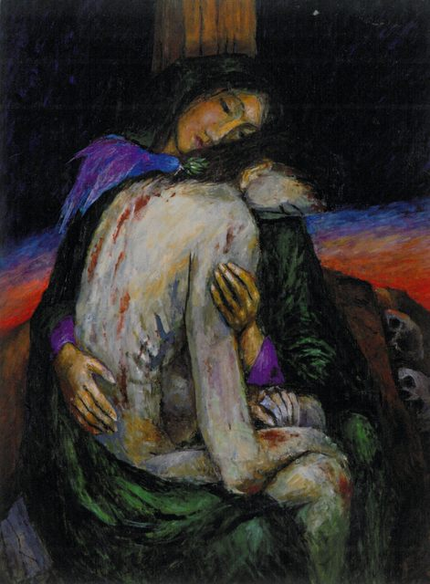
Mary and Joseph too marvelled. But then Simeon shared words which shocked Mary to the core. “This child is destined to cause the falling and rising of many in Israel … a sign that will be spoken against .. and a sword will pierce your own soul too.” Israel in turmoil? Mary distraught and broken hearted? Had she agreed to that when she willing responded to being God’s handmaiden? What had happened to those promises of peace and reconciliation? Salvation? Where was God in this? Had Simeon or even God got it wrong?

We found it hard to grasp that God’s blessing often comes in and through suffering. Surprisingly it’s often through suffering we discover the closeness of God. A fall has to come before the rising… a death before the resurrection … darkness before the light. The cross is never far from the crib – but God is in both – transforming and restoring. There is hope and new life.
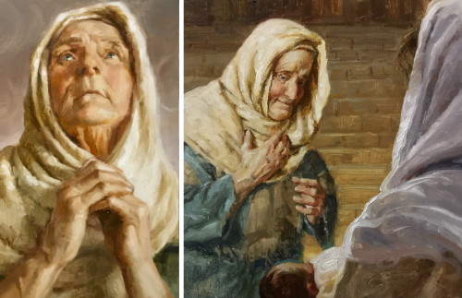
Anna certainly knew about suffering. A widow for many years but rather than looking back with regret she looked forward with hope. God had become her source of joy and contentment as she worshipped night and day, fasting and praying in the Temple. It couldn’t have been an easy life for a woman at that time! But she was in the right place at the right time! She was there when Mary and Joseph were there and coming up to them at that very moment, she overflowed with thankfulness to God. She recognised the fulfilment of God’s promises and couldn’t keep quiet about it. She told everyone! She must have blessed so many people that day and restored their hope too. It’s so good when we encourage one another and share what God has been doing in our lives.
The light isn’t just for the Temple or church – but is for everyone! We need to take it out there! We have a message of hope. Let’s look for ways of sharing what God has done in our lives with others and demonstrate His transforming love – especially at this time when there is so much darkness.

When we have waited long, when your promises seem empty,
when faith has grown tired and old, dazzle us with your darkness and light, illuminate the Way of Faith and Hope.
Restore us through your love and when our work is done, gather us to yourself and grant us peace. Amen (by Rachel Mann in A Star-filled Grace)

Rev. E Blackmore

