Jesus Cleanses the Temple

John 2:13-22

By Revd. George Roach.

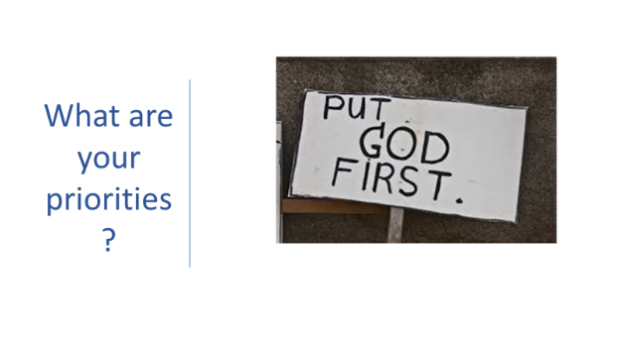
What are your priorities in life where G-d is concerned? This is the question I propose to you today.
So, how did you respond when you read Jesus Christ made a whip of cords and he drove out the people from the synagogue? How could such a seemingly placid man have what is often interpreted as a brief moment where he loses it a little bit? Does it leave us with a 2000-year-old message that says, “It is ok to have a moment”. Is it saying that it is ok to have a moment where your humanity spills forward as long as it is for all the right reasons and manifests for the right outcome? The key words here, are right reasons, right outcome.
Oh, how often have I had one of these moments, someone who is generally seen to be quite calm and level-headed has at times created my own cord and had my own moment. Sadly, not all of these moments have been for the right reasons or with the right outcome in mind., Again, this is my humanity here, and I guess you also have had these moments have you not? In fact, I would be surprised if you did not. But what is the right reason and the right outcome in relation to this scripture verse?
We need to remember that Jesus Christ was fully human and fully divine so it would indeed have been possible that this was a moment of anger that he had, or righteous anger as some would put it but it was not so much his mindset that was the question but rather the reason behind his mindset and the outcome it produced that we should look at within this story. What caused this situation in the first place?
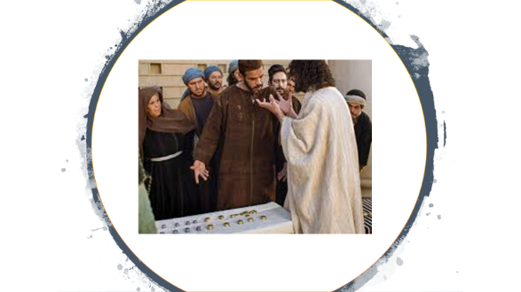
Well, it is highly possible that Jesus was upset that his father’s house was being abused, was this the abuse he found at the time or was it historical abuse of the temple? This we do not know. What we do know is that since an early age as a Jewish male his passion for His Father’s house has been growing all this time – and now, prayerfully, he realises that this could be time for action? Here I have a confession to make, this being that I feel I have been misreading this scripture verse since the beginning, and it is only through some ideas for alternative viewpoints from Eunice have I come to realise that this is not some much about Jesus “becoming angry” rather it is an expression of Jesus love for his father and all that his father stands for that is outpouring here, possibly a more direct way of saying “listen to me”.
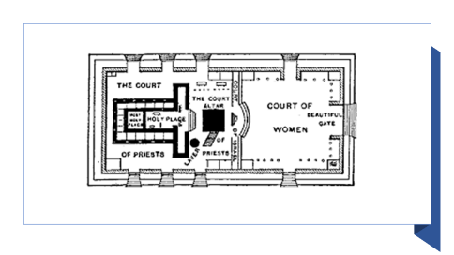
So, why did he feel the need to make this statement, well Jesus entered the temple, or his father’s house to find it not clean and tidy ready for worship but rather the opposite, and this had possibly been the case for some time however the Passover was a very special time in the calendar and as such the personal homes and the places of worship would have been cleaned spotlessly ready for this special time, however what Jesus finds is not a beautiful temple area but rather a place filled with filthy animals, with animal smells, with dirt and with noise.
Jesus also does not find the purity of the temple present; he finds the impurity of the money changers. Do not forget his words in the Gospel of Matthew,
“You cannot serve two masters (God and money), you will either love one more than the other”.
The temple should not, certainly during Passover, have had animals or money changers present and this would have been an obvious cause of Jesus anger. So not only does he find filthy animals in his father’s house, but he also finds people putting their own financial gain before the respect of the temple and its purpose of worship. In other words their priorities where wrong. Money and social status first, G-d last.
All of these would be the right reasons for the moments of righteous anger, but what would be the right outcome? Well, the right outcome in this story is to restore honour to G-d and order in his place of worship. These are two things, which a in my opinion are of utmost importance. It is in restoring honour and order that we clearly show a reflection of that which is truly in our heart. Our heart is demonstrated when we choose prayer over television; give to the poor and when we bring honour to G-d in his place of worship.
Those of you who know me know that I am a man of the saints and of the desert mothers and fathers, if you have never looked into the desert fathers…you are probably missing out, they are centuries old wisdom that looks at the scriptures and the Christian spiritual journey through very wise lenses and I love this saying from Abba Peomon who was a 3rd century desert father, in reply to the questions of Anger by one of his students…
“The right outcome cannot be seen while one is blind with rage”. – Abba.
What he is saying here is that in light of our Gospel reading Jesus had the right outcome (and motivation) in mind, his motivation was based on his love for God and all that G-d stood for which began not in the temple built from bricks and cement, rather from the depths of the human heart. It is here in the depths of the human heart does G-d see our attitudes and motivation towards him. It is the human heart that shows outwardly how we treat his place of worship, each other and many other things relating. It interests me to think that if this was motivated by Jesus seeing long before this event into the hearts of those that where there how much has he seen in my heart and yours?
So, my question I leave with you is, in light of this story is,
What are your priorities in life? Does money come first, maybe status and finally the honour and worship of G-d or where you one of those ones watching from outside the temple in agreement as the tables where overturned?
Let us pray…
Almighty G-d let our anger be controlled, our hearts be at peace, out motives be of right reasons and right outcome and if we fail help us to learn from a repentant heat so that in all thing’s others may see a reflection of you. In Jesus name we pray,
Amen.

