Sermon for June 20th 2021
Father’s Day

In the name of the Father, and of the Son and of the Holy Spirit. Amen.
Lord, take my words and speak through them; take our thoughts and think through them; take our hearts and hold them in the palm of your hand.
Before the card and gift companies hijacked Father’s Day for their own commercial reasons, St Joseph’s Day was commemorated in honour of St Joseph who stood by Mary and raised Jesus as his own son. Fathers and Father figures have always come in all shapes, sizes and disguises…and today we have an opportunity to celebrate them.
When I was a little girl, my dad was my hero-in my eyes he could do no wrong. And it was fairly obvious that in his eyes, I could do no wrong either! He taught me my alphabet and how to count before I went to school; he took me to the kennels to choose my first puppy and he gave me sixpence a week pocket money which was an absolute fortune back in the day! We were best friends right up to the day he died. We loved each other for over 60 years and there will always be a dad shaped hole in my heart. I was very lucky to have my dad and I thank God for him every day, just as many of us here, and some of you watching at home, were lucky to have your own dad. But sadly, not everyone can say that and Father’s Day can be a day of mixed emotions and difficult memories.
I hope that today God the Father’s love is felt by all of us.

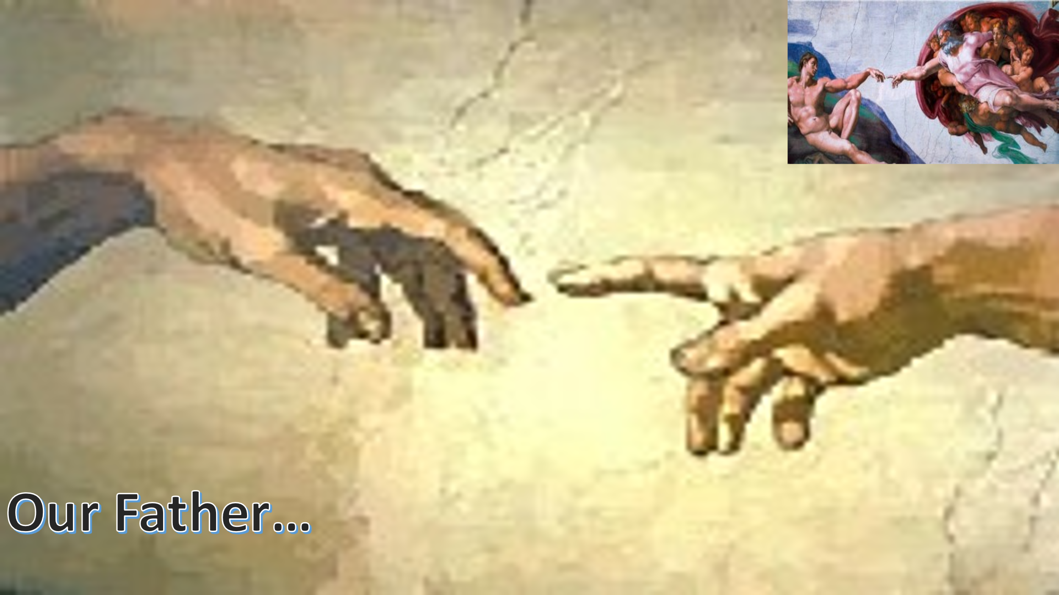
Now, unlike our vicar and many of you, I have never been to Jerusalem – But I have been to Rome where I saw this incredible painting by Michael Angelo on the ceiling of the Sistine chapel. God reaching out to Adam… reaching out to give him life. I was awestruck and whenever I see a photo of it I am reminded that God is indeed our Heavenly Father. He reaches out to us every day. Every day he calls us his children and invites us to call him Father. (I have never seen a ‘Happy Father’s Day’ card for God in the shops though. Have you?)
When Jesus showed us how to pray, he began with the words ‘OUR FATHER’… if those words were good enough for Jesus, they are certainly good enough for me! That prayer has become central to our relationship and communication with God. When our own words fail us (and mine often do) the rhythm of these words take us straight to the heart of God the Father who invites us to share his Kingdom.

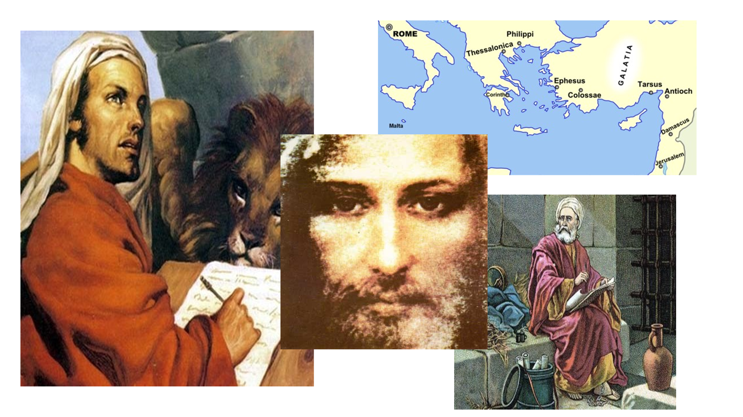
Whenever anything significant happens in our world, we hear about it almost instantly via social media, TV and radio. The Newspapers are a bit slower to catch up as journalists write their copy to be approved by their editors before being sent to print.
When Jesus was here, there was no twitter, Instagram or Facebook, there was only word of mouth and scrolls… so the writers of the New Testament had to work pretty quickly to share their memories and stories about the Messiah. After his ‘Jesus moment’ on the road to Damascus, Paul felt compelled to travel as far as he could to share the message of Jesus, God and the Kingdom. He became a man of many, many letters which we are still reading 2000 years after he wrote them. I might not like everything he wrote, especially about women, but I have to admire his passionate determination. He suffered the most awful experiences but his faith was unshakeable and his legacy of words is priceless. No matter how hard our lives might be, no matter what dreadful things we might experience, and the last 18 months have certainly been very hard, he urges us to remember that NOW is the right time to reach out to God. NOW is the day of Salvation.
When Mark wrote his gospel, he did it at breakneck speed. He has given us a 15-chapter biography of Jesus which vividly chronicles the man, his parables, healings and miracles. He wrote quickly… wanting to get every detail recorded for posterity. There is an urgency in his writing. He needed to share Jesus’ story without any delay and that’s the theme picked up by Paul. This is a gospel that was meant to read out loud… and if you have a couple of hours available, and you haven’t heard David Suchet read the whole of Mark’s gospel I can hugely recommend that you search for it on YouTube…it’s magnificent!

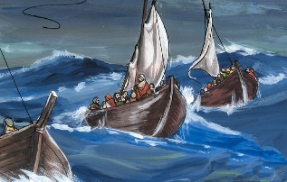
In just 6 verses today, Mark shares the drama of what happened when Jesus asked his disciples to take him and their boats across to the other side of the Sea of Galilee. Obviously, they did as he asked and he trusted their skills so completely he went for a nap in one of the boats. But a dreadful storm blew up which frightened the life out these very experienced fishermen whom he had called to be his disciples. If it frightened James and John, the sons of thunder, it must have been spectacular! They woke Jesus up, asking if he even cared if they drowned?

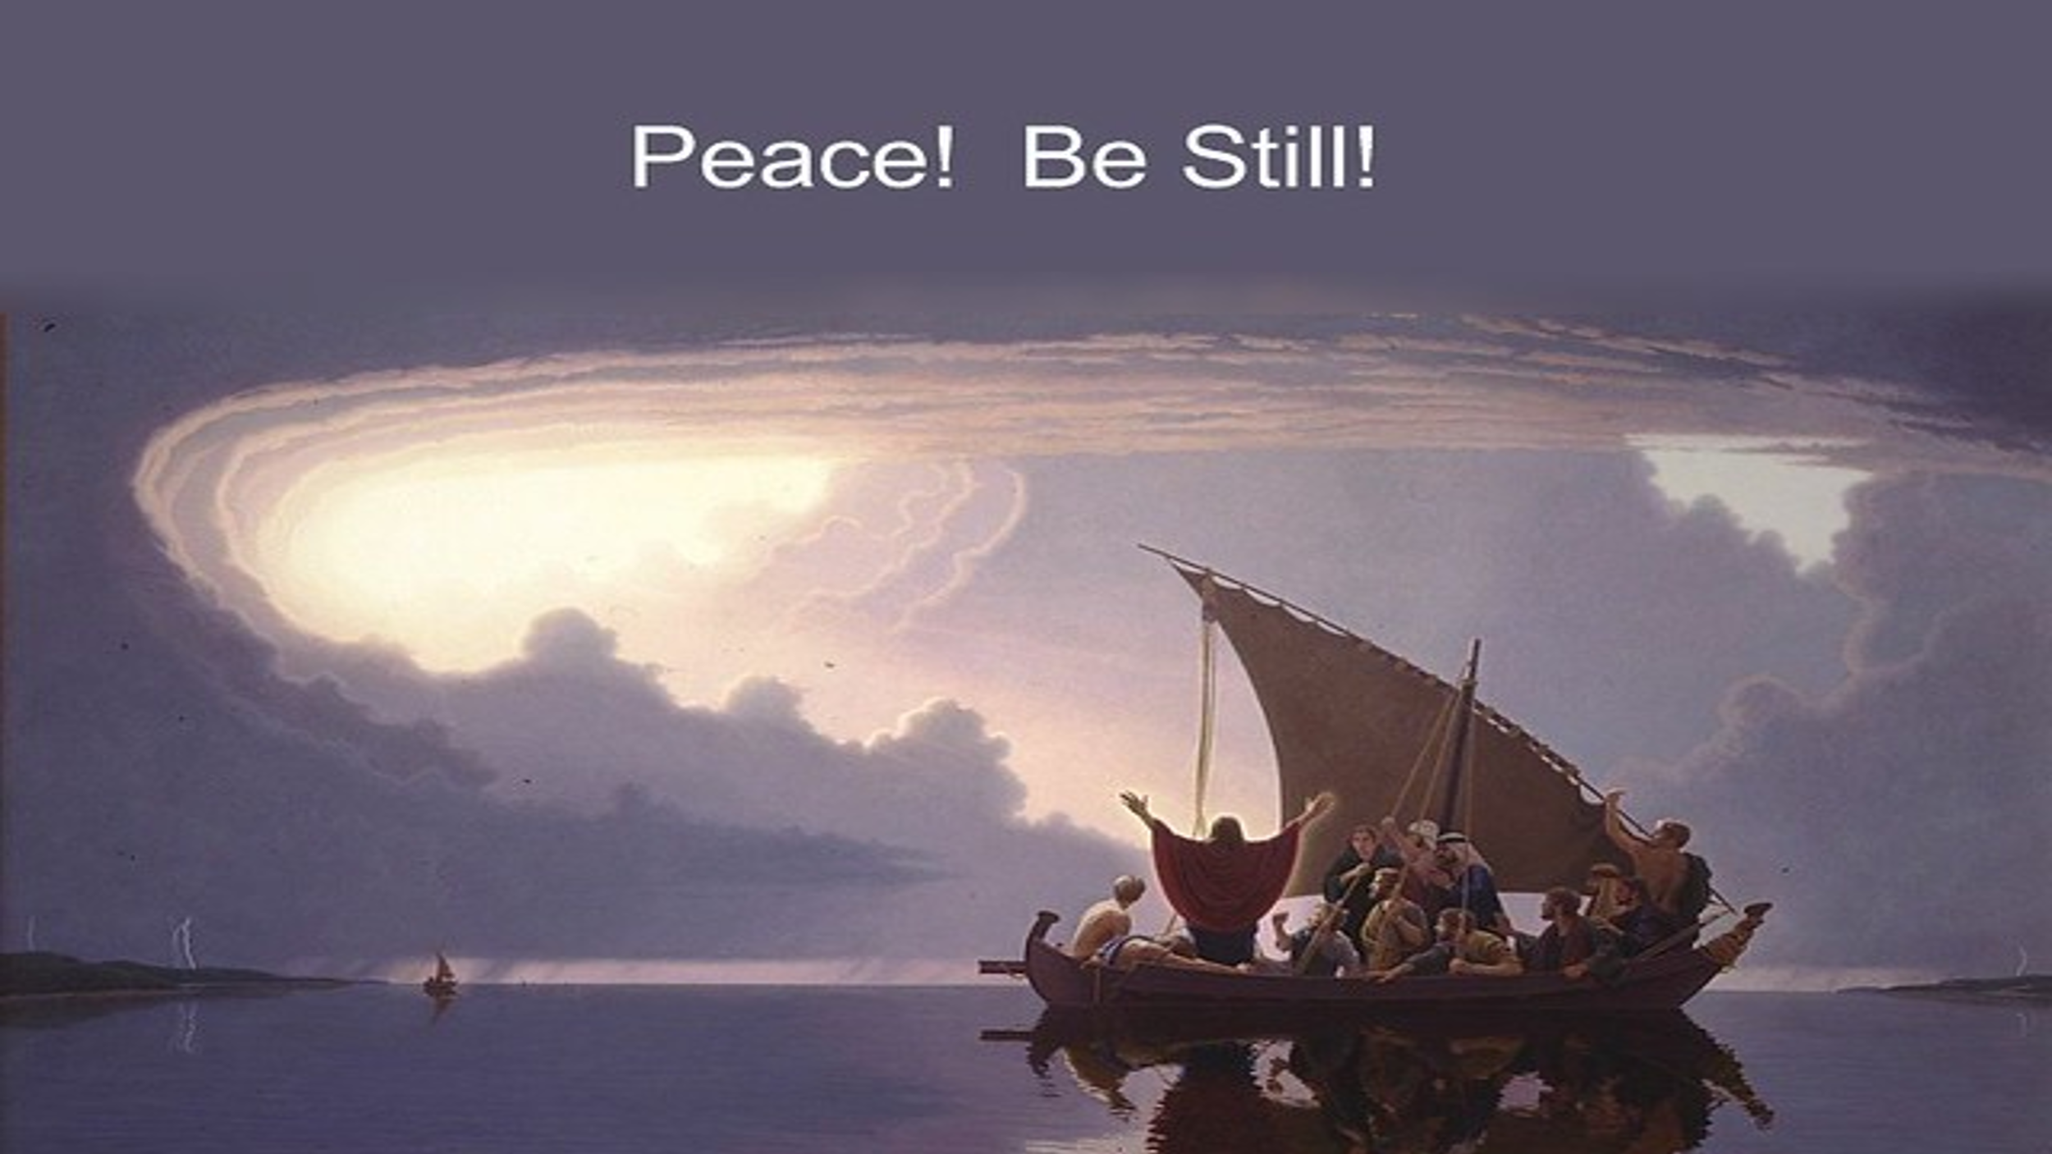
Jesus simply stood up, and told the winds and the waves to be still. And they were. I’m not sure whether the disciples were more scared of the storm itself or the fact that Jesus simply had to raise a hand and stay ‘Be Still’. They learned a lot about faith that day. Jesus was listening to their fears and in calming the wind and the waves, he calmed their fears too.
When we are in the middle of our own storms and we ask for God’s help, he is always listening. God our Father never sleeps. He is always listening. We simply have to be still and know that He and is with us in our boats.

On the news sheet you will find this lovely quote:
Isn’t it amazing that our awesome God who made night and day, land and sea, planets and stars, also calls us his children and invites us to call him Father? ‘We believe in one God, the Father Almighty…
I mentioned earlier that I hadn’t seen any Father’s Day cards for God… but in your pews, or on the tables nearby, you will find postcards. All based on this theme…
Please take one with you and use it to write your own Father’s Day message to Him. Not necessarily today…He is always here.
Or there.
Everywhere really.
And if you are at home, perhaps you could just write him a note on your own paper?
I think He would be absolutely delighted to hear from us on Father’s Day!
Amen.

